Name: Jay Sheth
Roll Number: 2328
Division: D

Q.1 Use the filtering functionality of Wireshark by typing “dns” in
the filtering field, new window will appear:
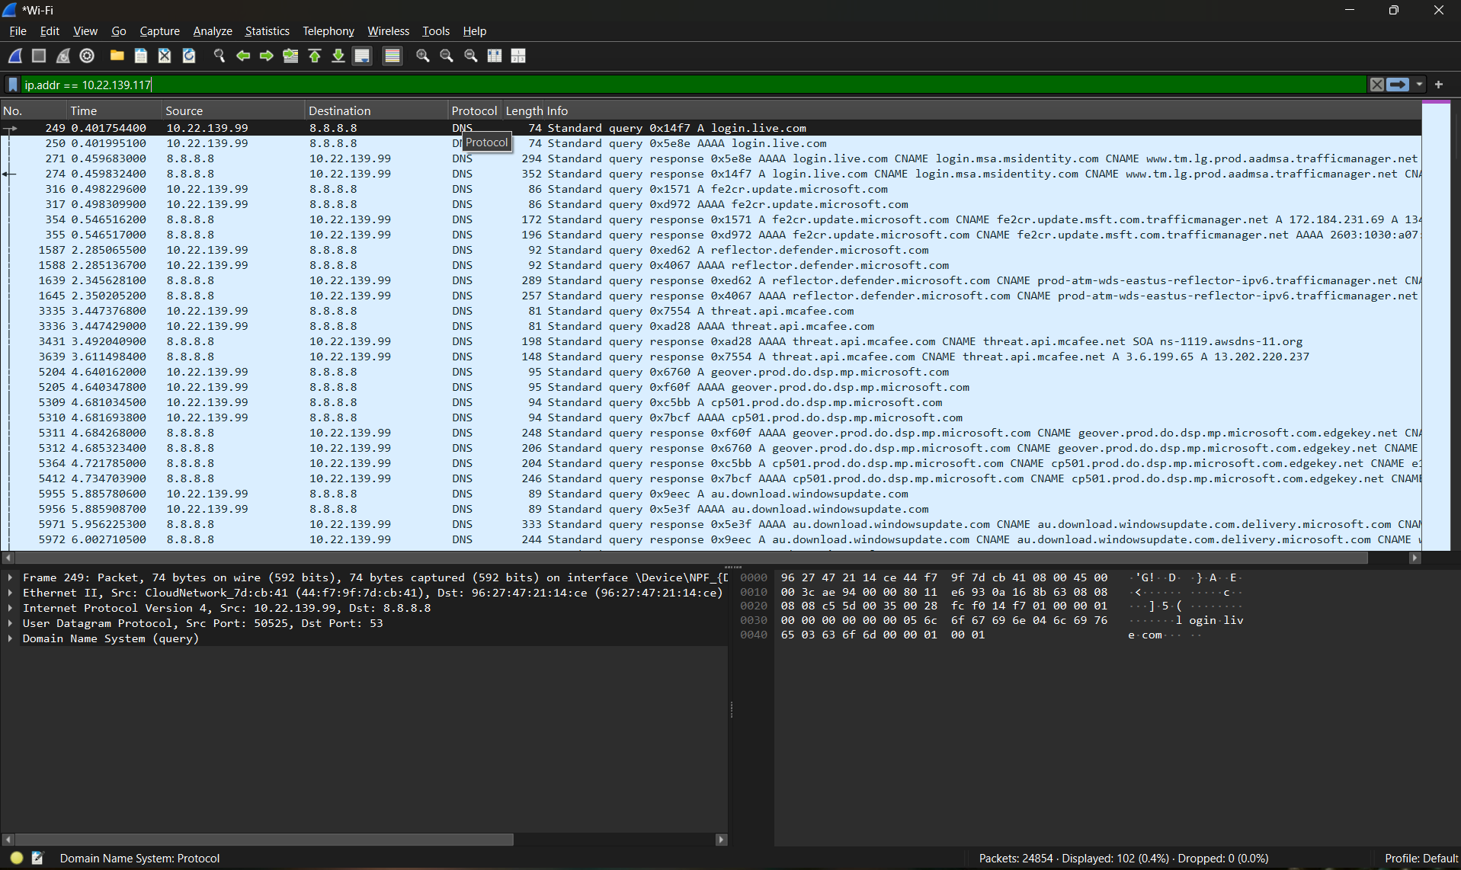

Q.2 Let’s try now to find out what are those packets contain by
following one of the conversations (also called network flows),
select one of the packets and press the right mouse button, you
should see another screen appear.

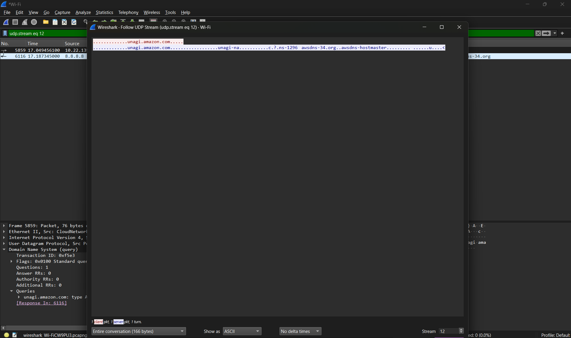

Q.3 At Command prompt; Nslookuphttps://www.amazon.com/

From this command we can find the ip address of amazon

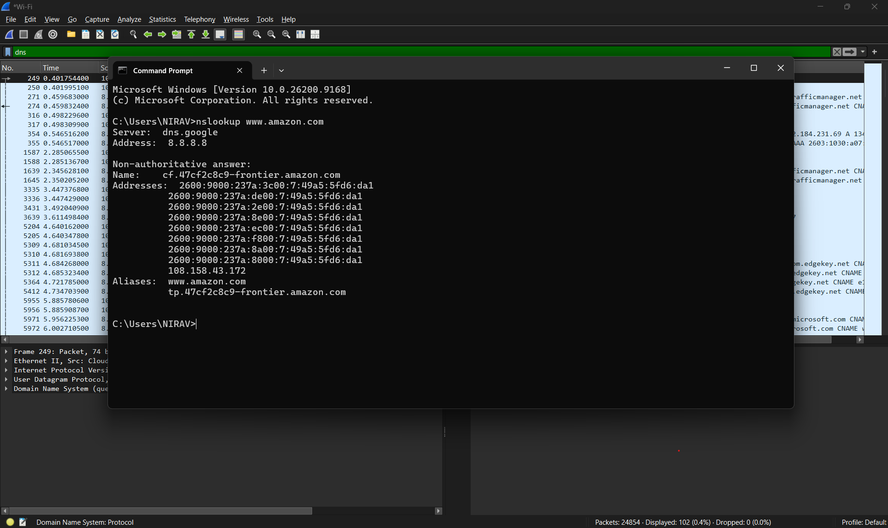

Q.4 Locate the DNS Query and Response message, Are they sent on
UDP or TCP ?

The DNS Query and DNS Response are sent using the UDP protocol
(Protocol 17).
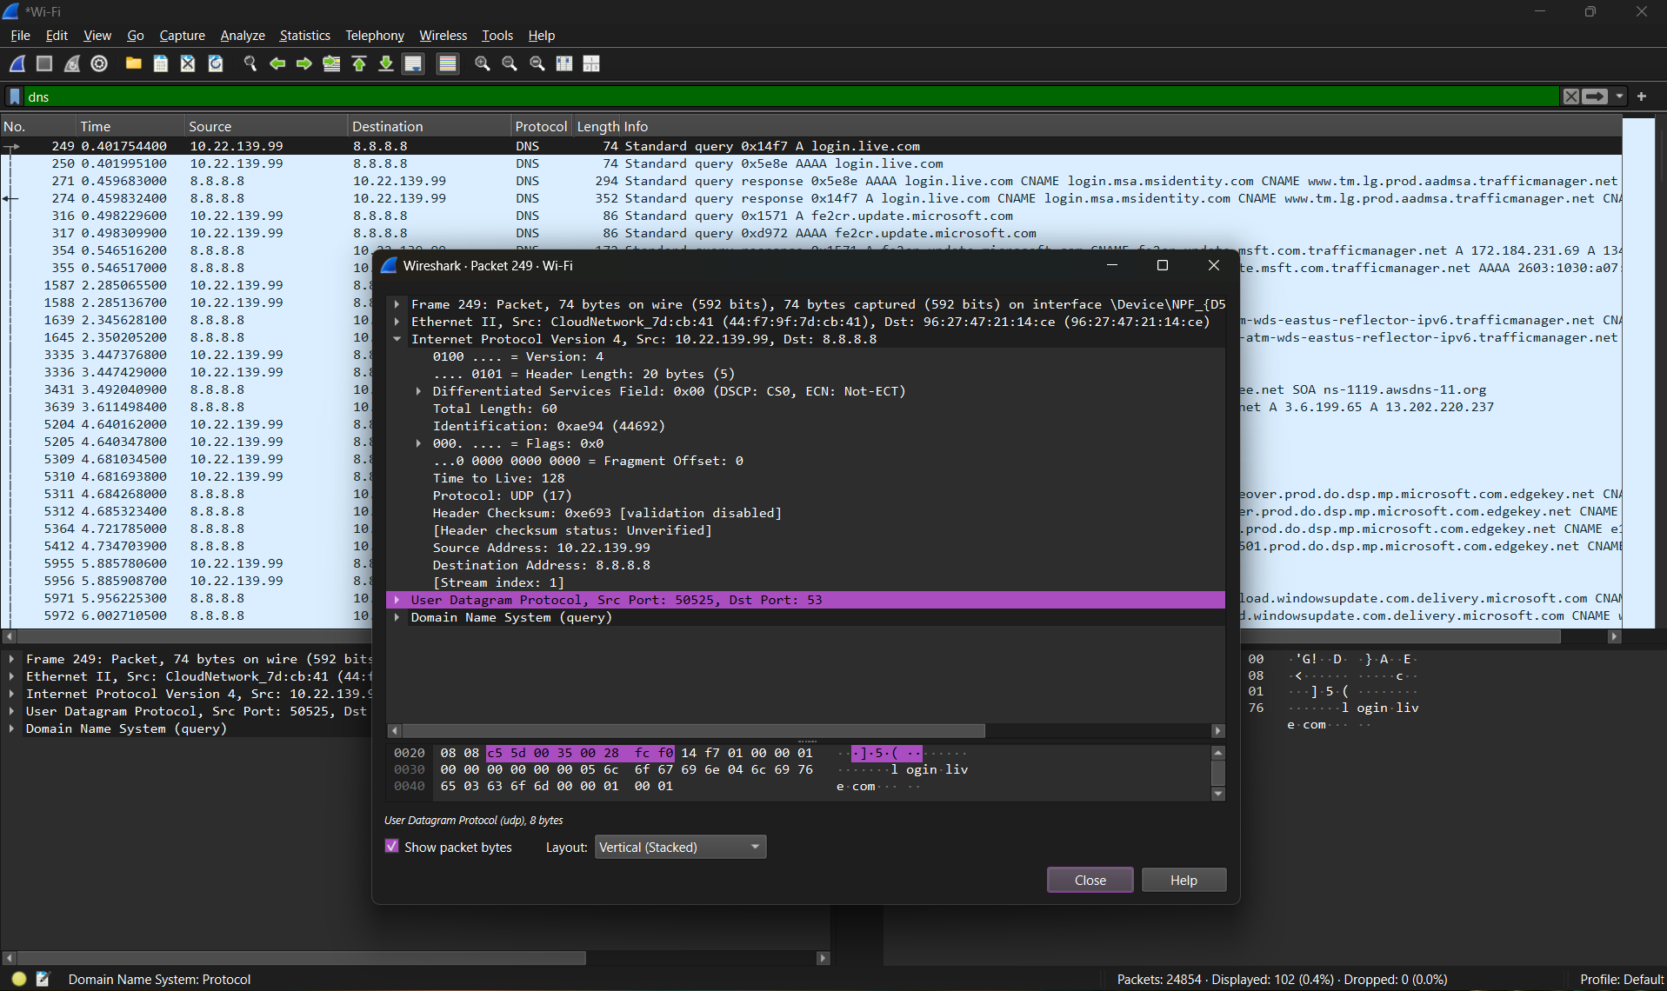

Q.5 What is the destination port for the DNS query message ? Whatis the source port of of DNS response message?

The destination port for the DNS Query message is Port 53, and the source port for the DNSResponse message is also Port 53.
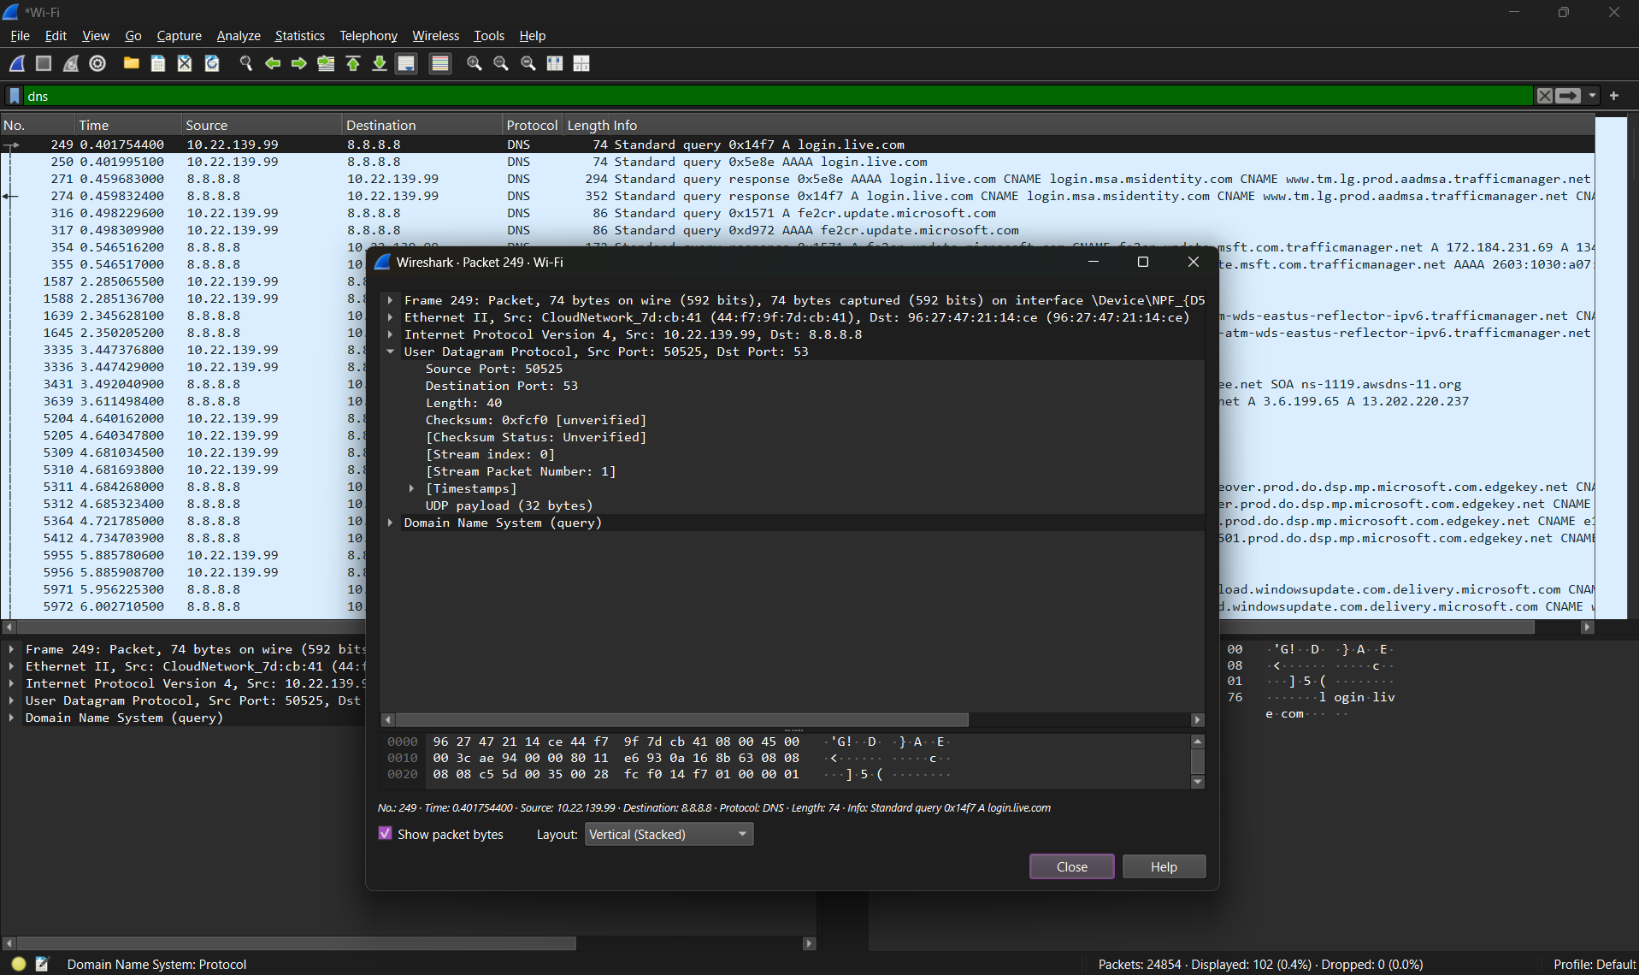
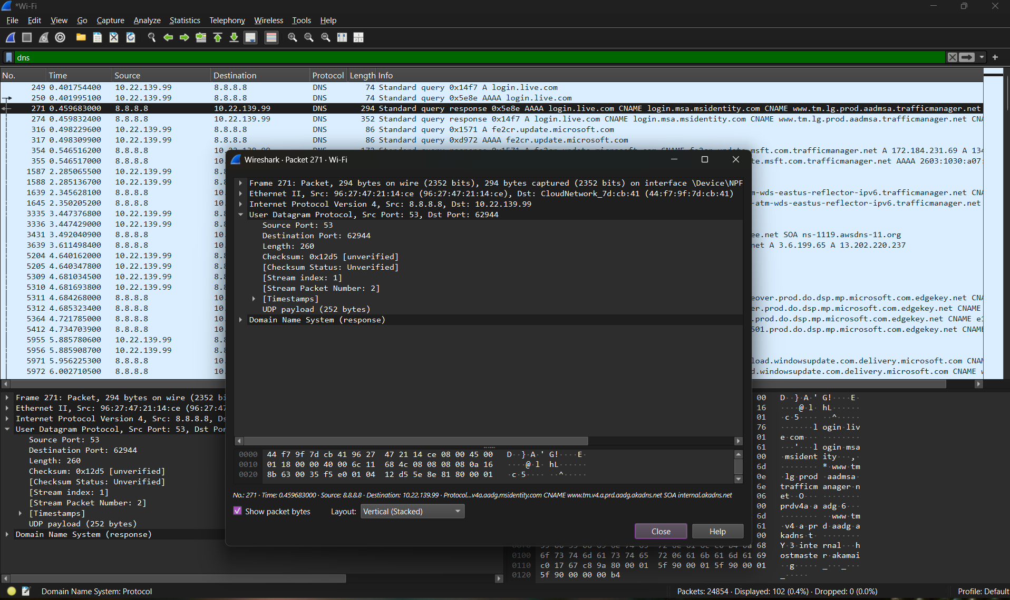

Q.6 What is the source IP address of the DNS Query message? Is it theIP address of your computer? Verify using ipconfig. Are these twoIP address the same?

Yes , computer ip address and DNS query msg are same
Computer Ip Address = 10.22.139.99
DNS Query message = 10.22.139.99
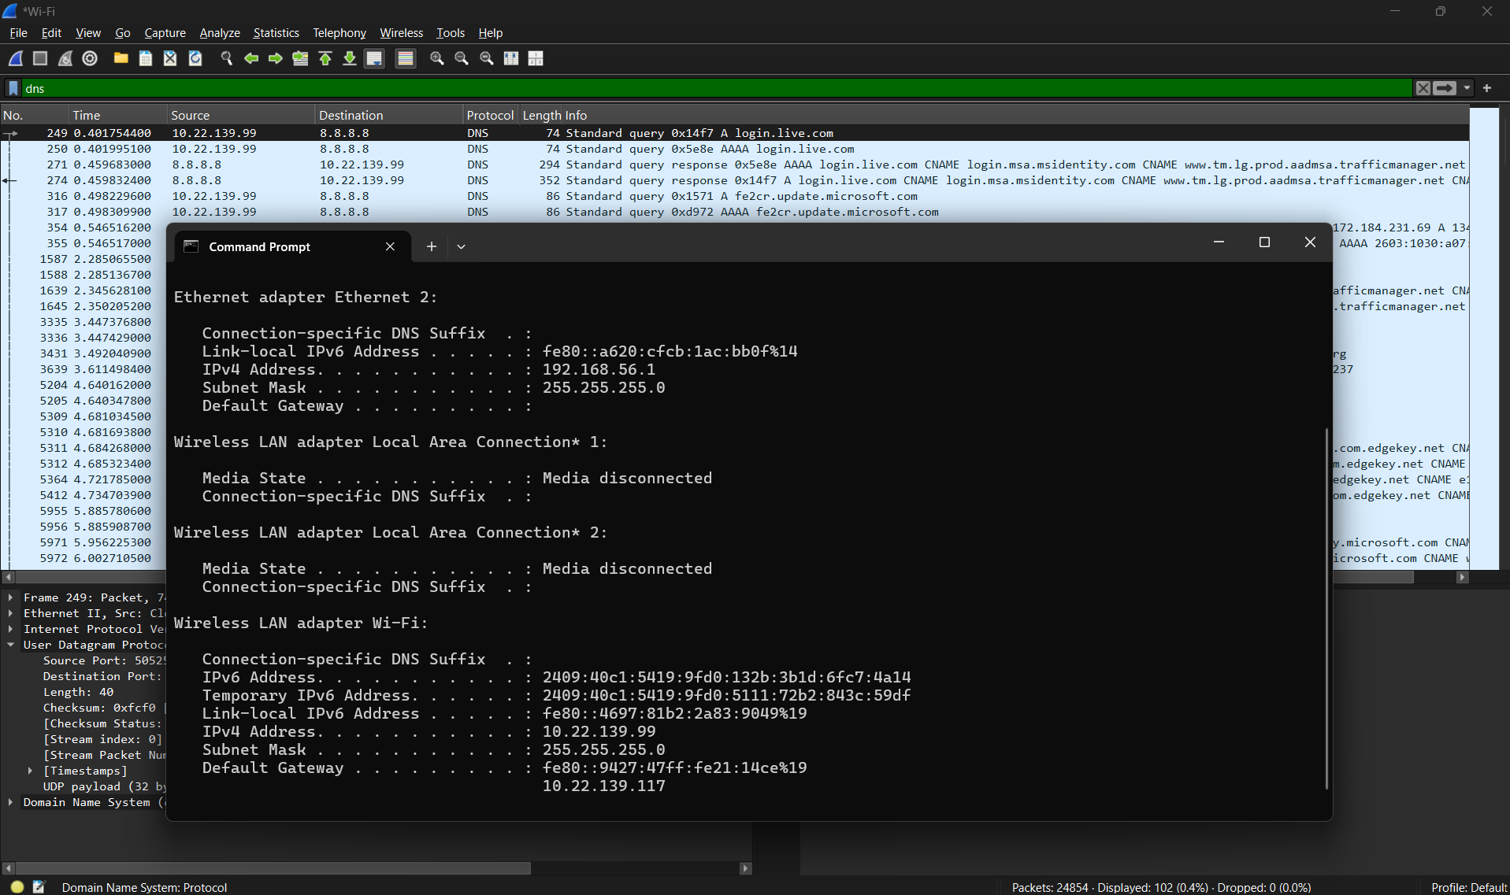

Q.7 What is the destination IP address of the DNS Query message? Is itthe IP address of your local DNS server? Verify using ipconfig. Arethese two IP address the same?

Yes , destination IP address of the DNS Query message and Ip address of local DNS server is same
Ip Add of DNS query = 8.8.8.8
DNS server = 8.8.8.8
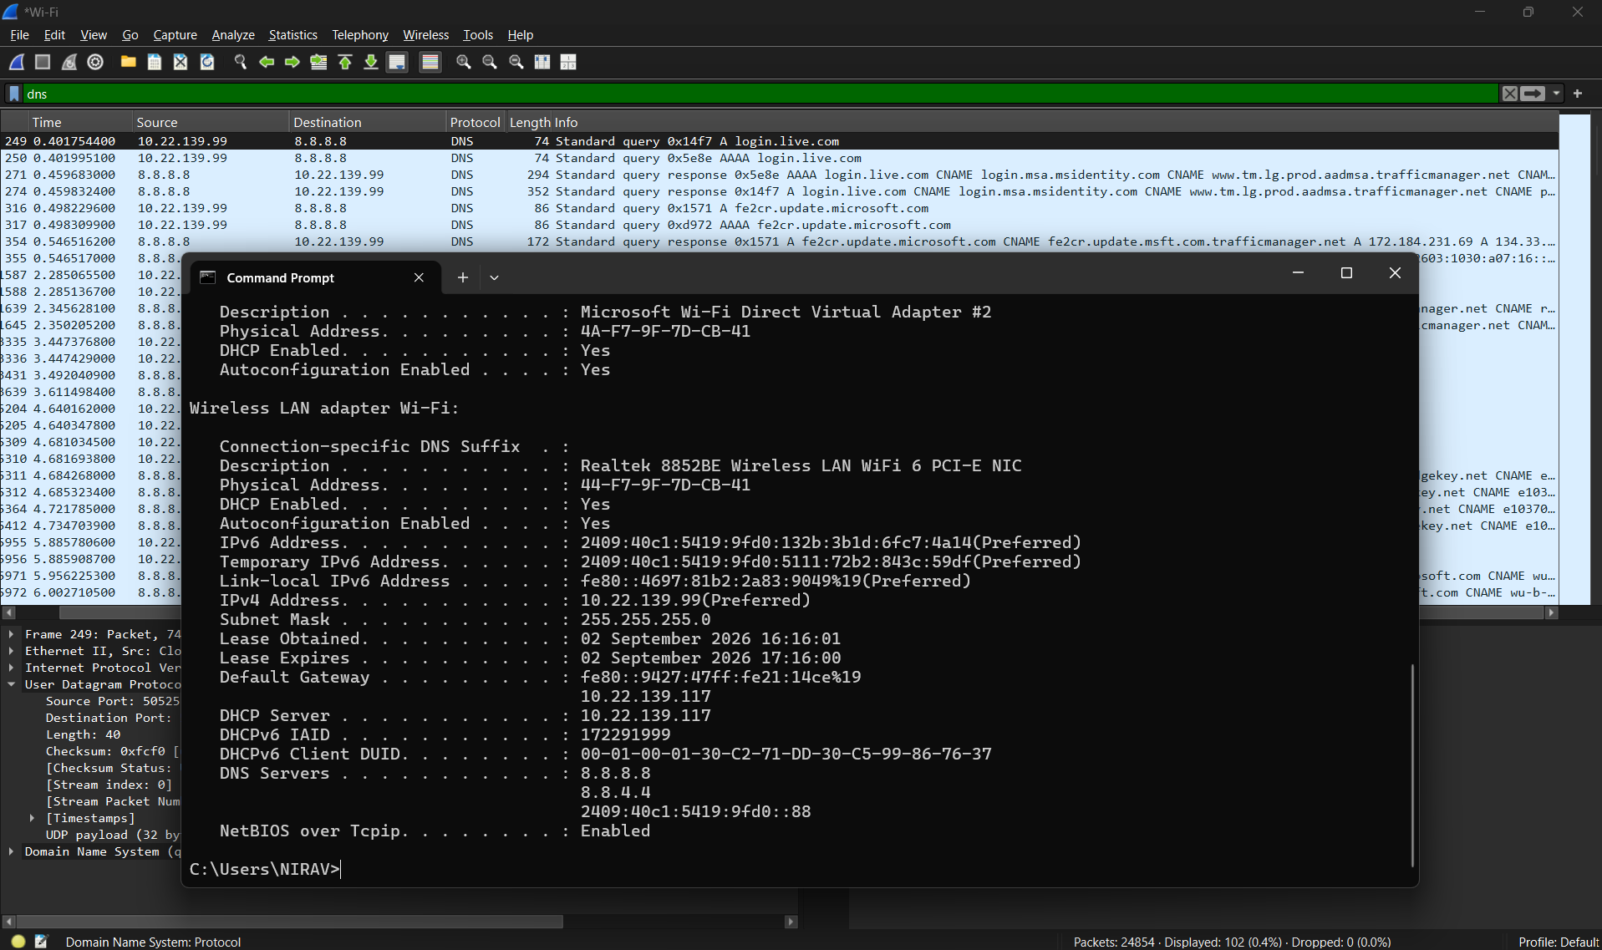

Q.8 Examine the DNS query message. What “Type” of DNS query isit? Does the query message contain any “answers”?
Type = HTTPS
Answer = 0
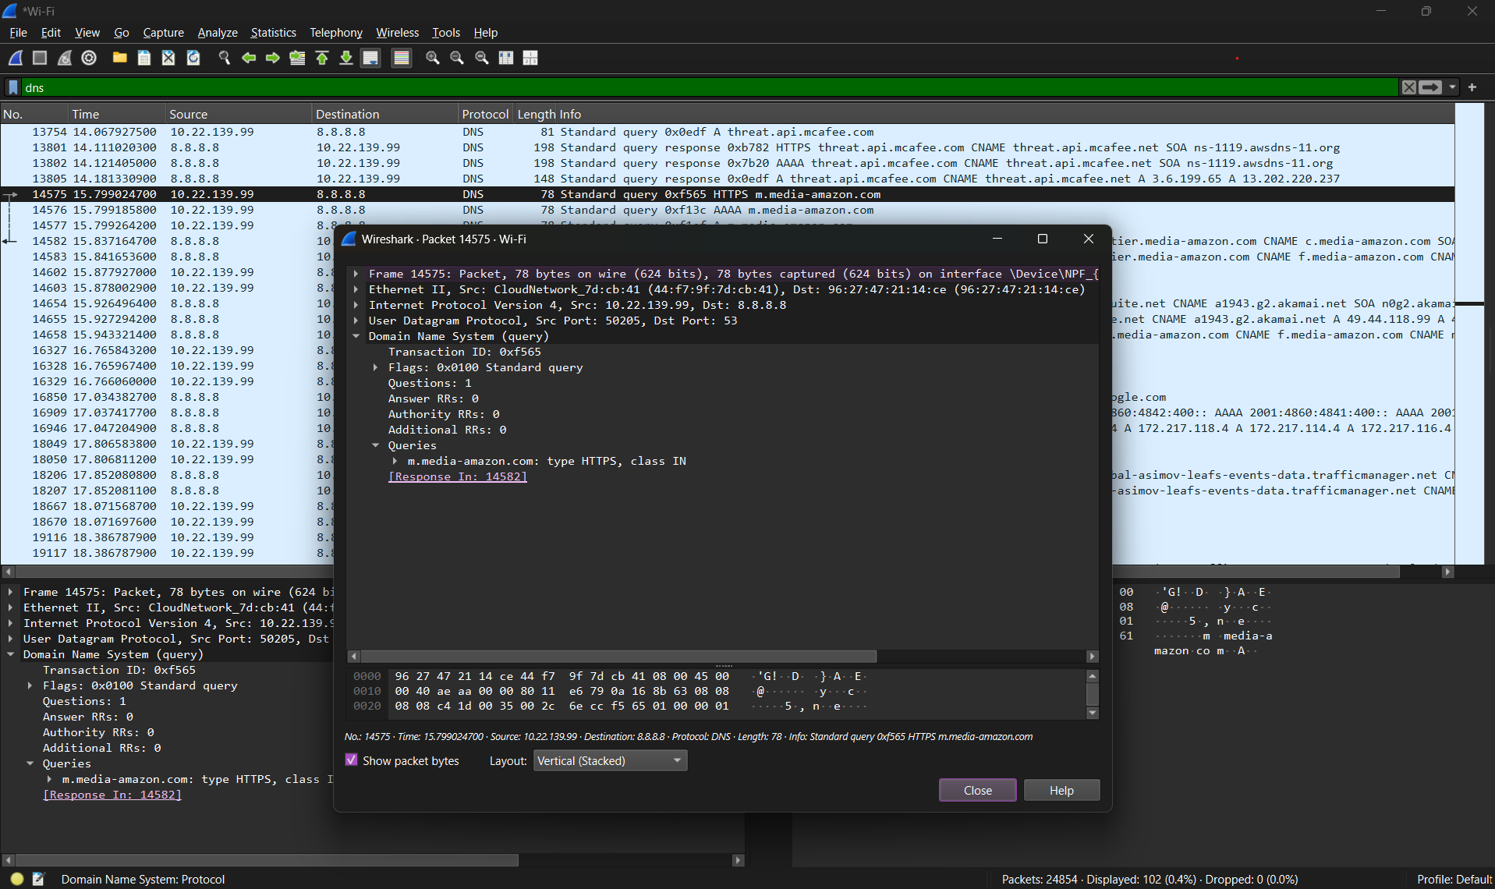

Q.9 Examine the DNS response message. How many “answers” areprovided? What do each of these answers contain?
DNS response has 1 answer.
Name: ungi.amazon.com
Type: CNAME (5) (Canonical NAME for alias)
Class: IN (0x0001)
TTL: 26 (26 second)
Data Length: 11
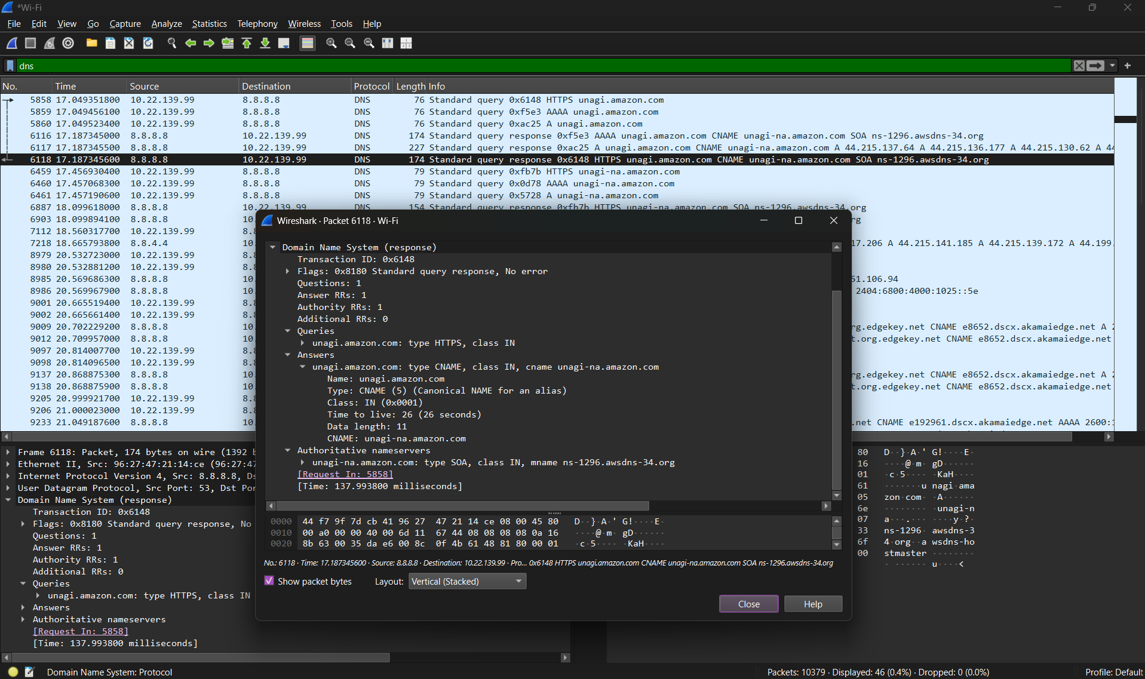

Q.10 What Protocol use in Payload? How many bytes use in Payload?
For DNS request UDP protocol is used and that has 32 Bytes Payload
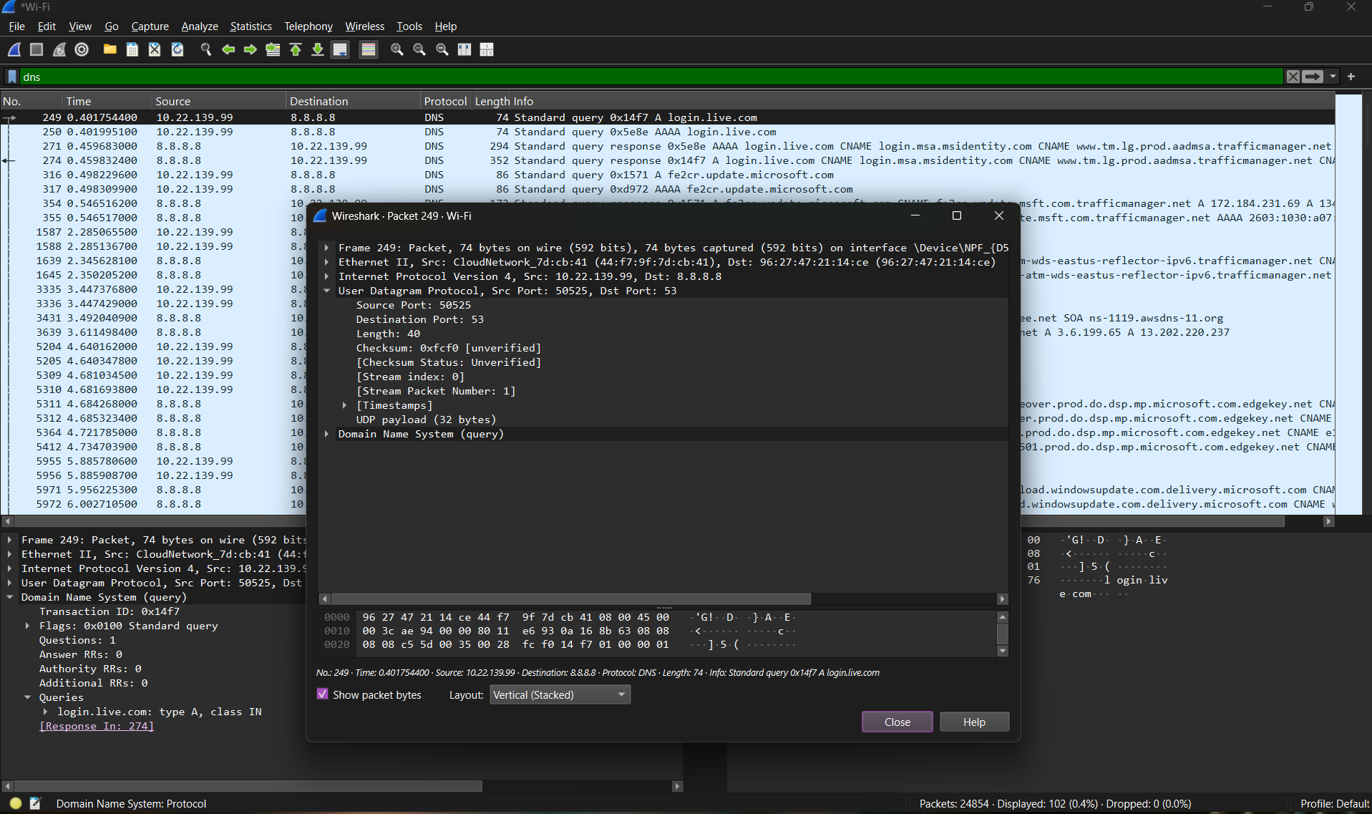

For DNS response UDP protocol is used that has 310 Bytes Payload
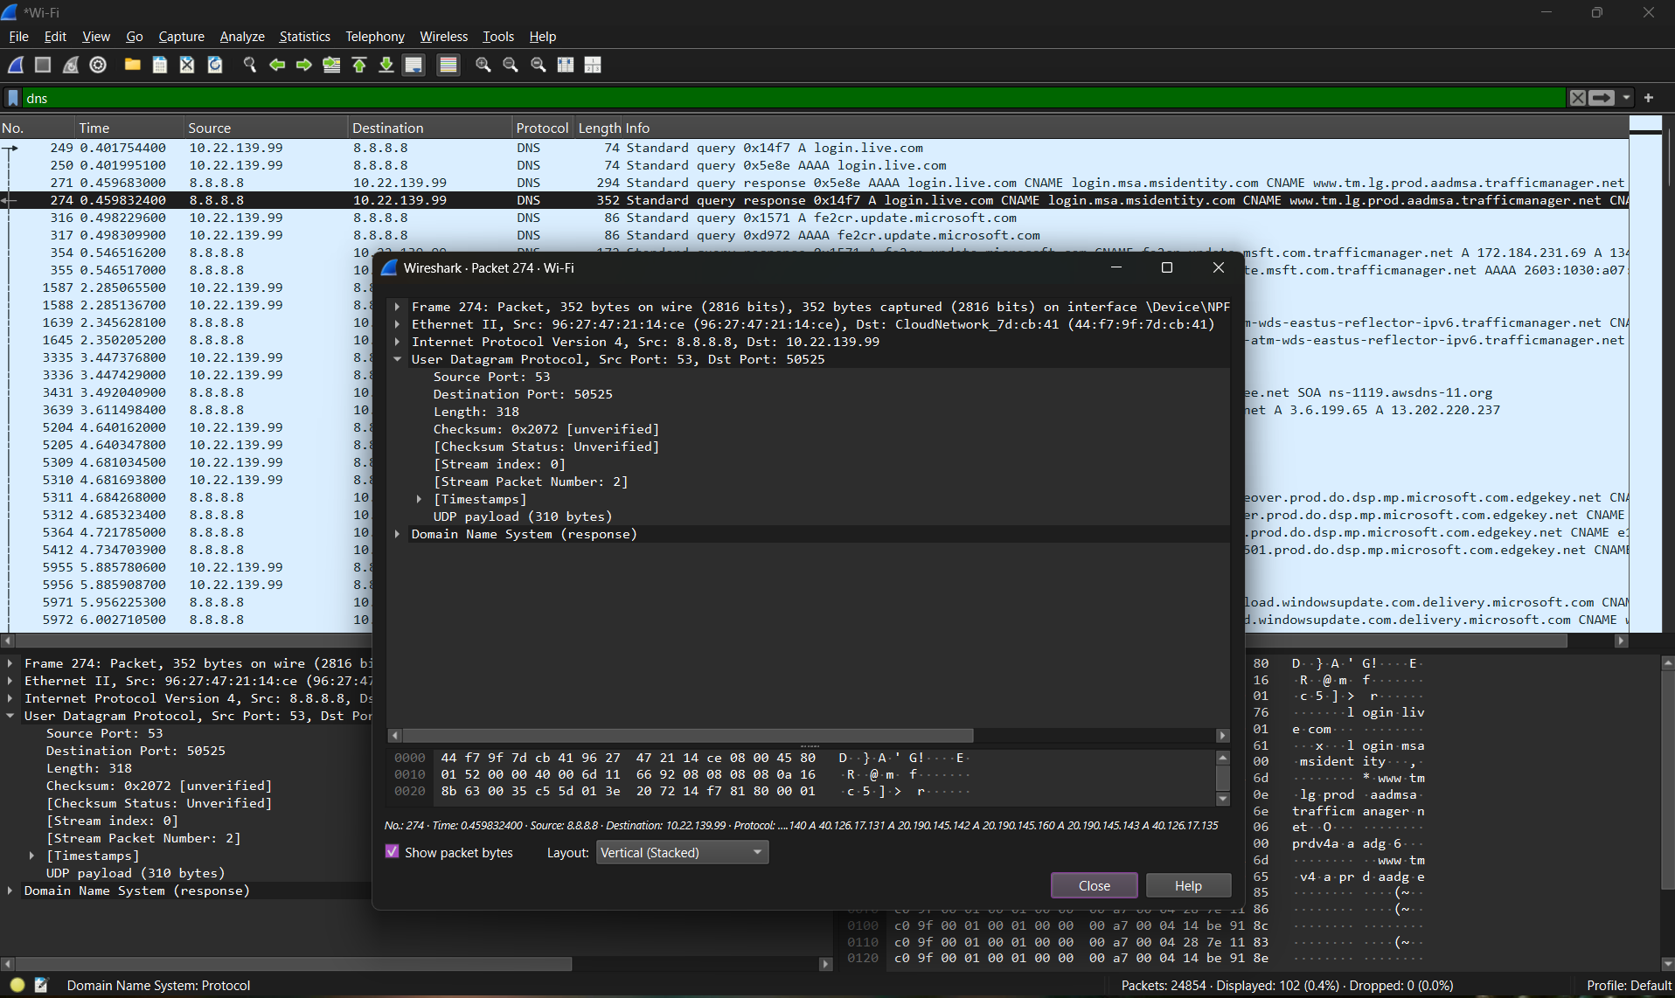

Q.11 Find stream index and stream packet number of DNS Response.
When we make request , the stream index and stream packet number both are 1.
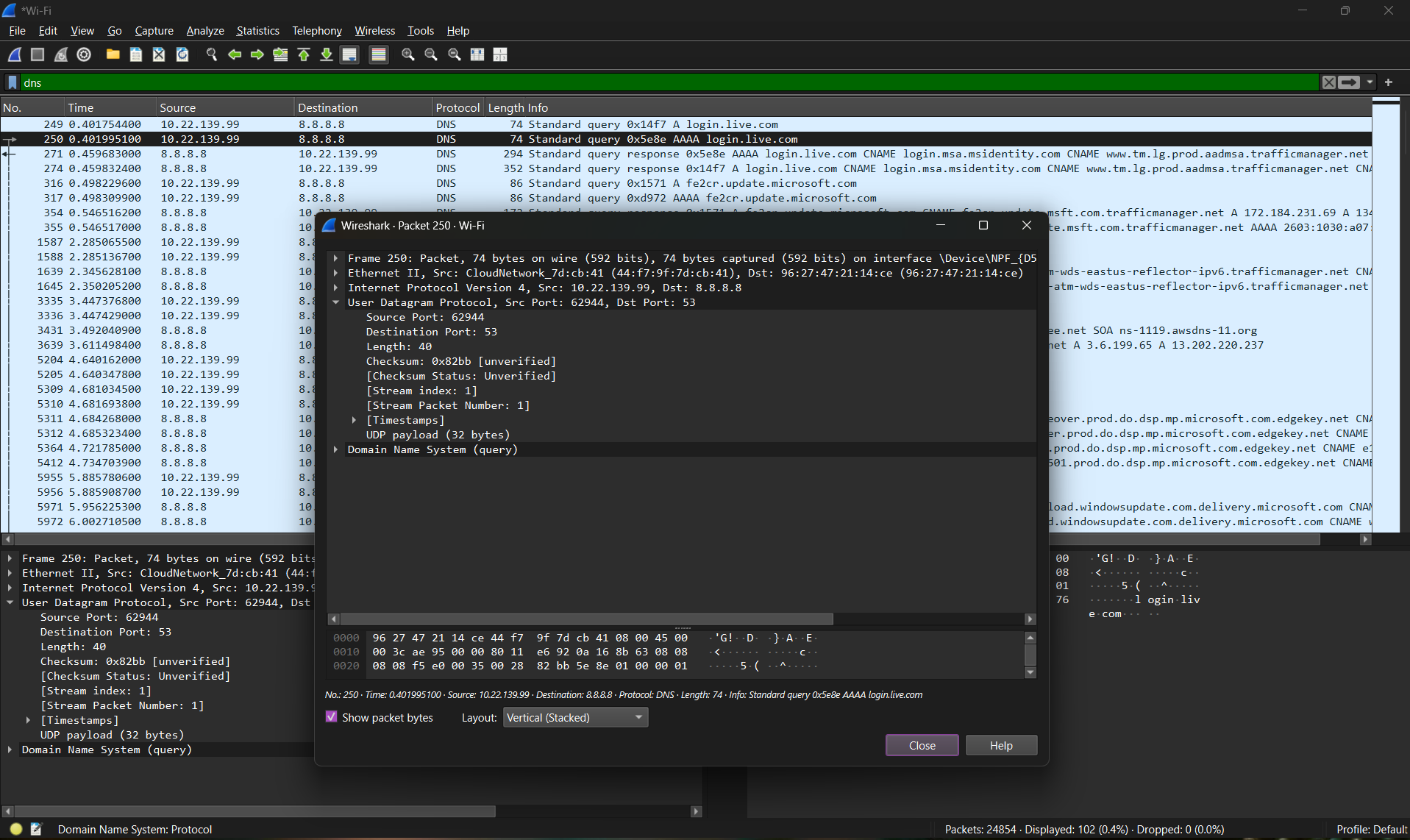

When we receive a response , the stream index is 1 and stream packet number is 2.
